**MYSQL – TASK 1**

**Exercise 1: Queries**

1. SELECT title FROM movies;
2. SELECT director FROM movies;
3. SELECT title, director FROM movies;
4. SELECT title, year FROM movies;
5. SELECT * FROM movies;

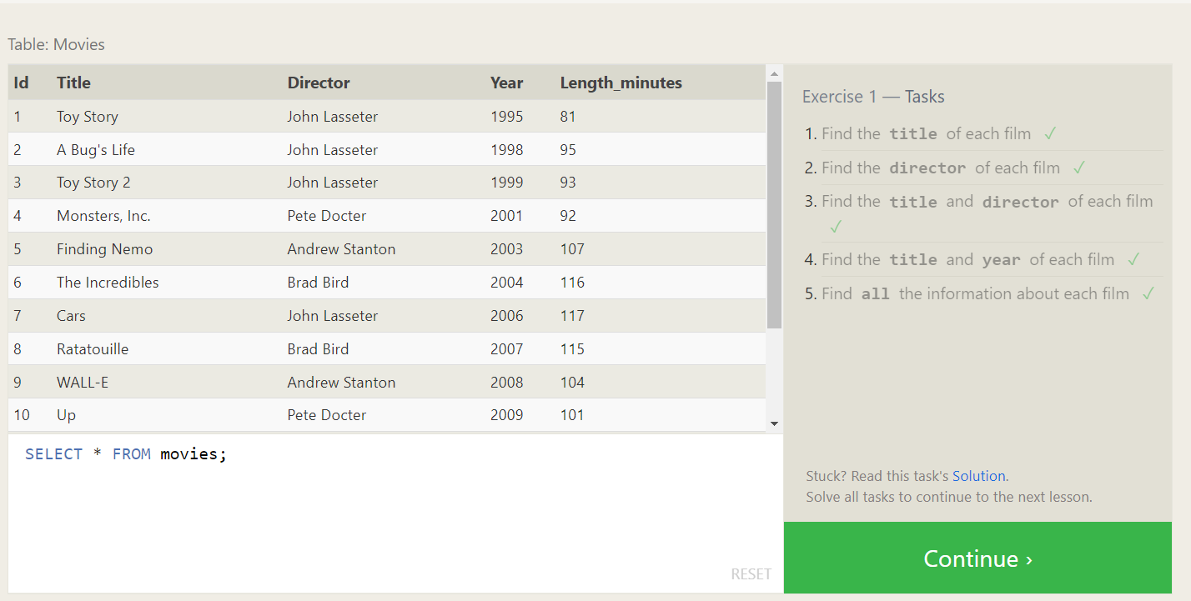

**Exercise 2: Selected Queries**

1. SELECT * FROM movies where id=6;
2. SELECT * FROM movies where year between 2000 and 2010;
3. SELECT * FROM movies where year not between 2000 and 2010;
4. SELECT * FROM movies where id<=5;

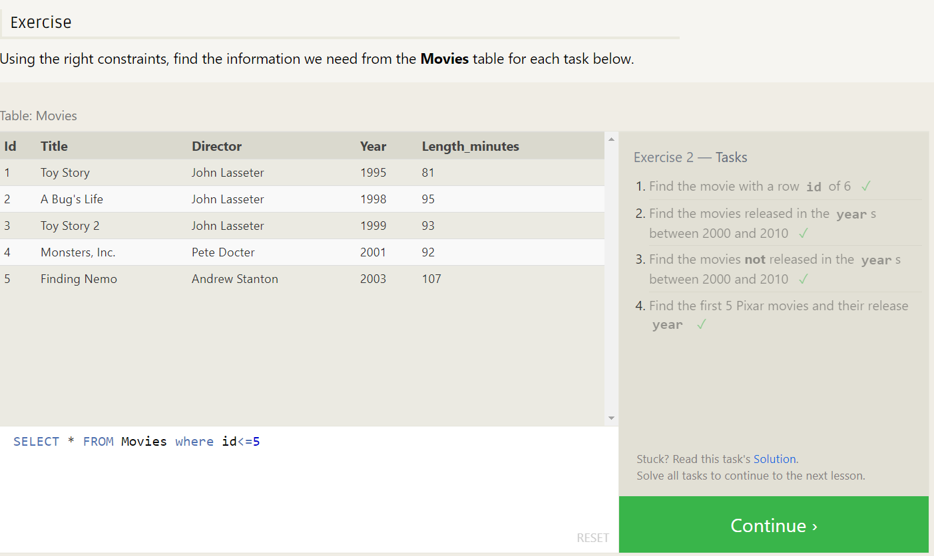

**Exercise 3: Queries with Constraints**

1. SELECT * FROM movies where title like 'Toy Story%';
2. SELECT * FROM movies where director='John Lasseter'
3. SELECT * FROM movies where director!='John Lasseter'
4. SELECT * FROM movies where title like "WALL-_";

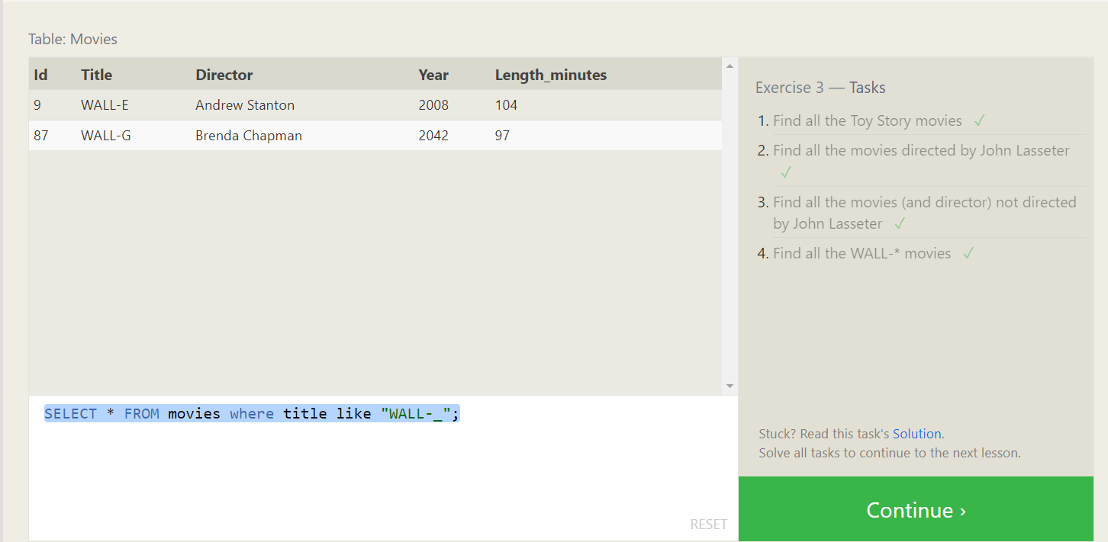

**Exercise 4: Filtering and Sorting Query Results**

1. SELECT distinct director FROM movies order by director;
2. SELECT * from movies order by year desc limit 4;
3. SELECT * from movies order by title asc limit 5;
4. SELECT * from movies order by title asc limit 5 offset 5;

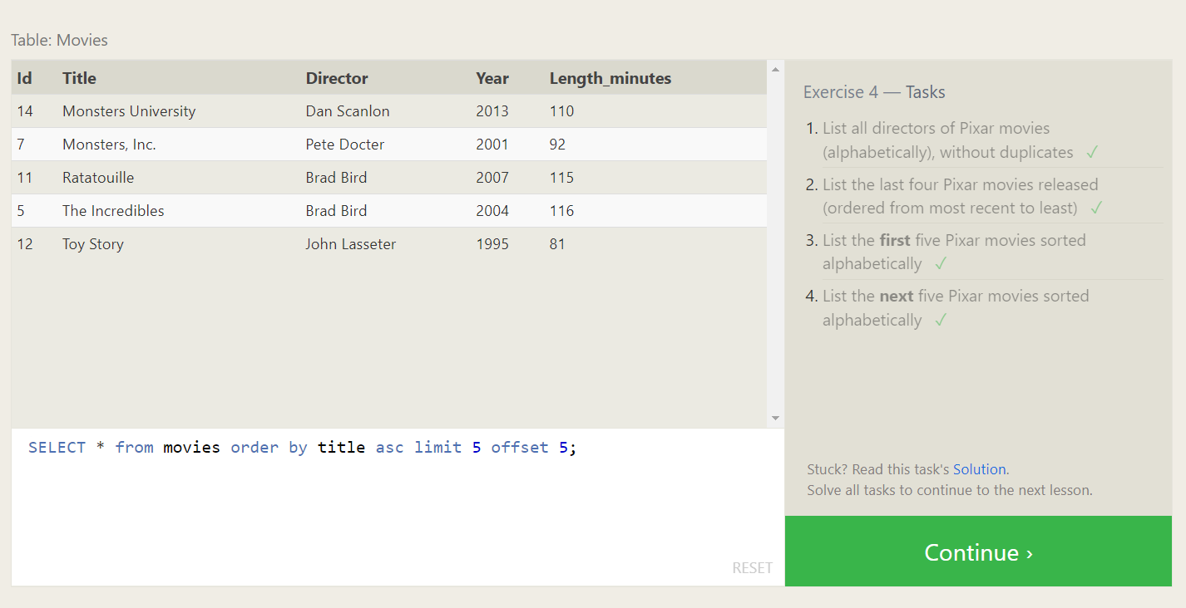

**Exercise 5: Simple Select Queries**

1. SELECT City, population FROM north_american_cities where country like 'Canada';
2. SELECT * from North_american_cities where country='United States' order by latitude desc
3. SELECT * from North_american_cities where longitude<-87.629798 order by longitude
4. SELECT * from North_american_cities where country='Mexico' order by population desc limit 2
5. SELECT * from North_american_cities where country='United States' order by population desc limit 2 offset 2

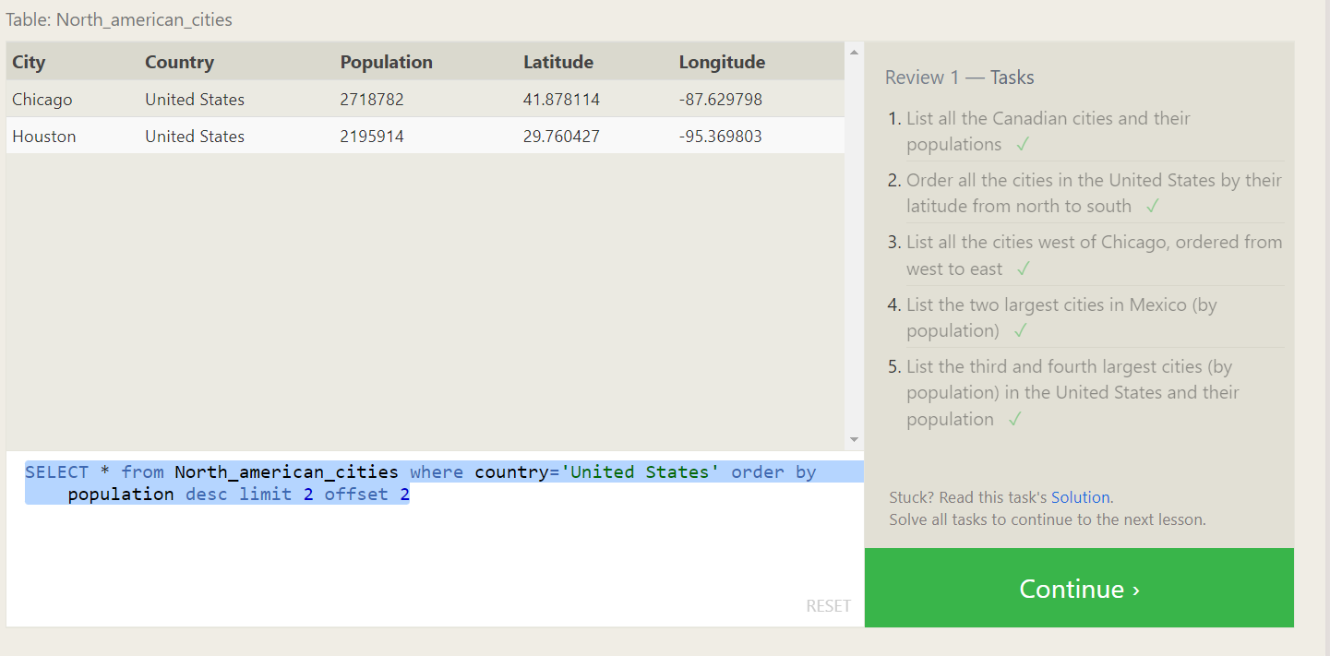

**Exercise 6: Multi table queries with joins**

1. SELECT * FROM movies m join boxoffice b on m.id=b.movie_id;
2. SELECT * FROM movies m join boxoffice b on m.id=b.movie_id where

b.International_sales>b.Domestic_sales;

3. SELECT title FROM movies m join boxoffice b on m.id=b.movie_id order by b.rating desc;

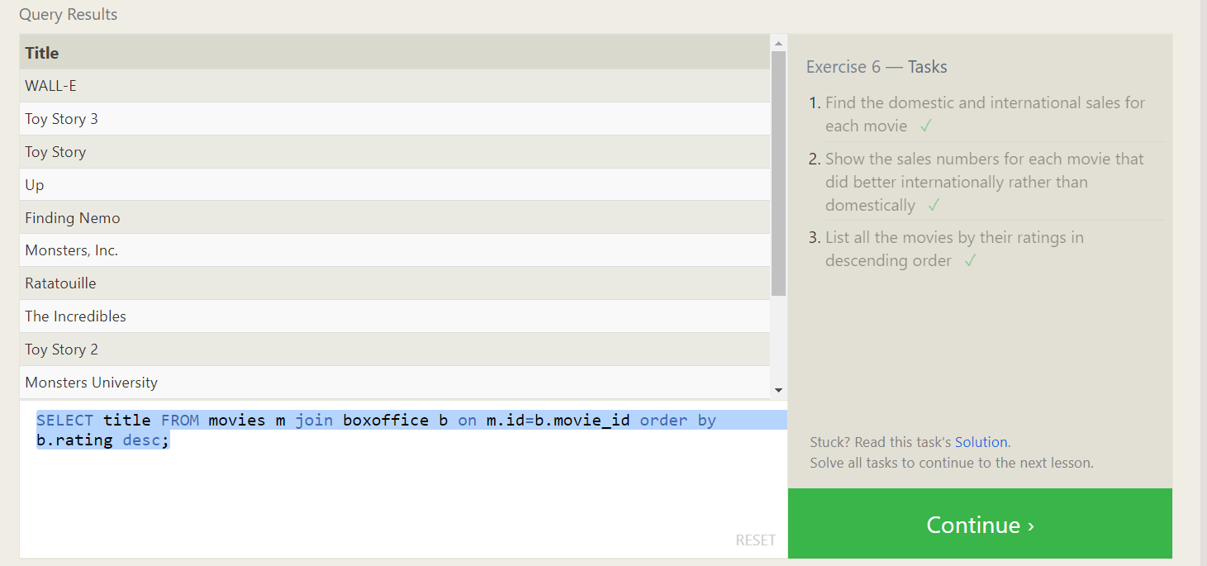

**Exercise 7: Outer Joins**

1. SELECT distinct building FROM employees;
2. SELECT * from Buildings;
3. SELECT distinct (Building_name), role FROM Buildings LEFT JOIN Employees on Building_name=building;

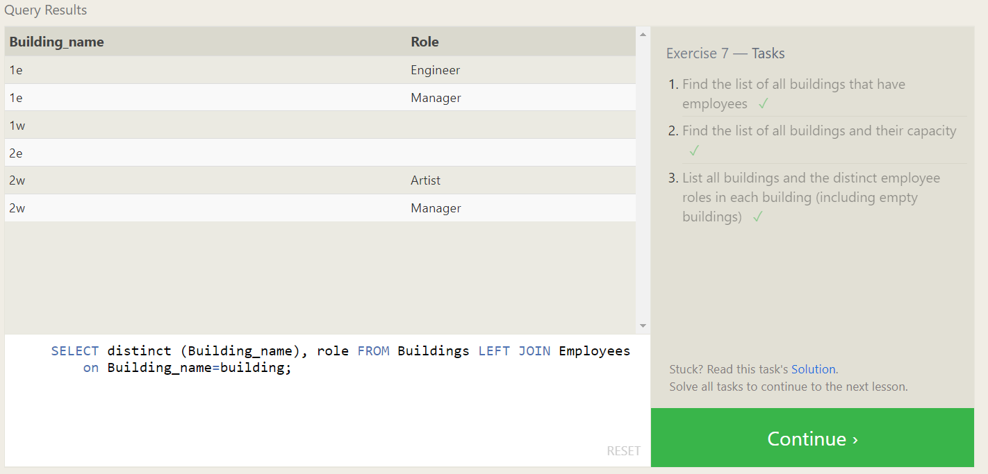

**Exercise 8: A short note on nulls**

1. SELECT * FROM employees where building is null;
2. SELECT * FROM buildings left join employees on Building_name=Building where building is null;

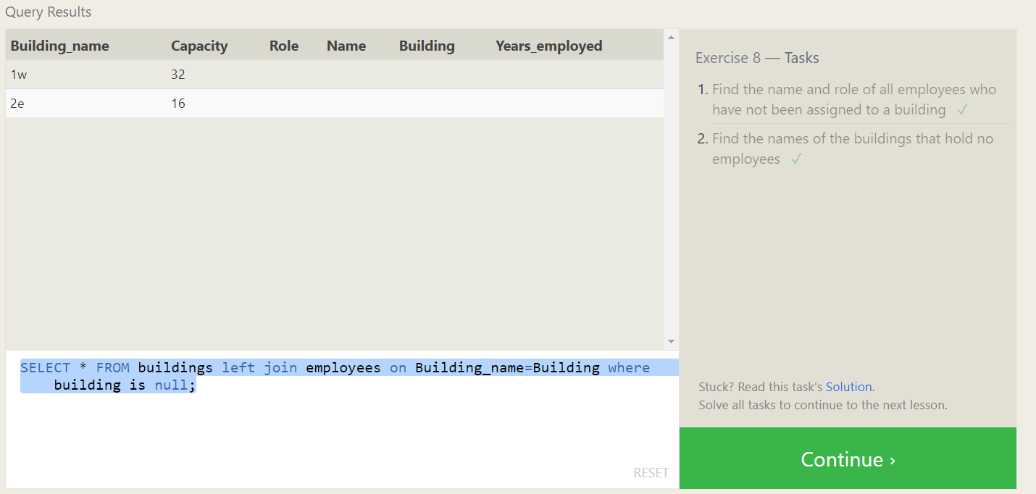

**Exercise 9: Queries with Expresssions**

1. SELECT title, (domestic_sales + international_sales) / 1000000 AS gross_sales_millions FROM movies JOIN boxoffice ON movies.id = boxoffice.movie_id;
2. SELECT title, rating * 10 AS rating_percent FROM movies JOIN boxoffice ON movies.id = boxoffice.movie_id;
3. SELECT title, year FROM movies WHERE year % 2 = 0;

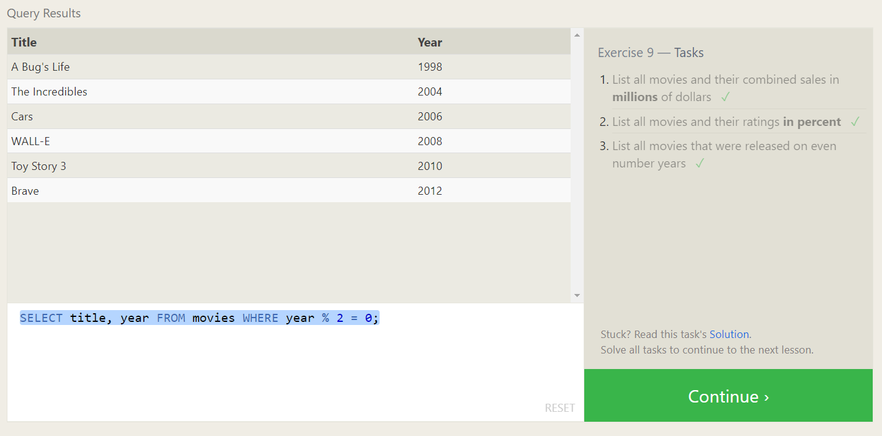

**Exercise 10: Queries with Aggregates**

1. SELECT MAX(years_employed) as Max_years_employed FROM employees;

2. SELECT role, AVG(years_employed) as Average_years_employed FROM employees GROUP BY role;

3. SELECT building, SUM(years_employed) as Total_years_employed

FROM employees GROUP BY building;

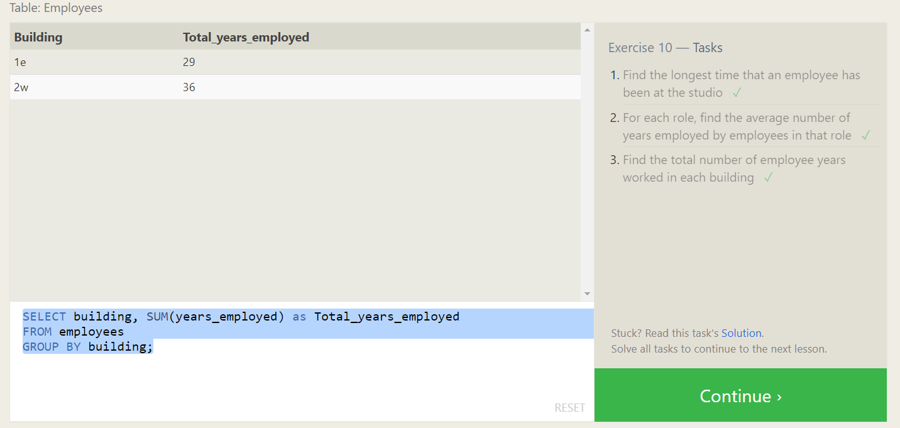

**Exercise 11: Queries with aggregates**

1. SELECT role, COUNT(*) as Number_of_artists FROM employees WHERE role = "Artist";

2. SELECT role, COUNT(*) FROM employees GROUP BY role;

3. SELECT role, SUM(years_employed) FROM employees GROUP BY role HAVING role = "Engineer";

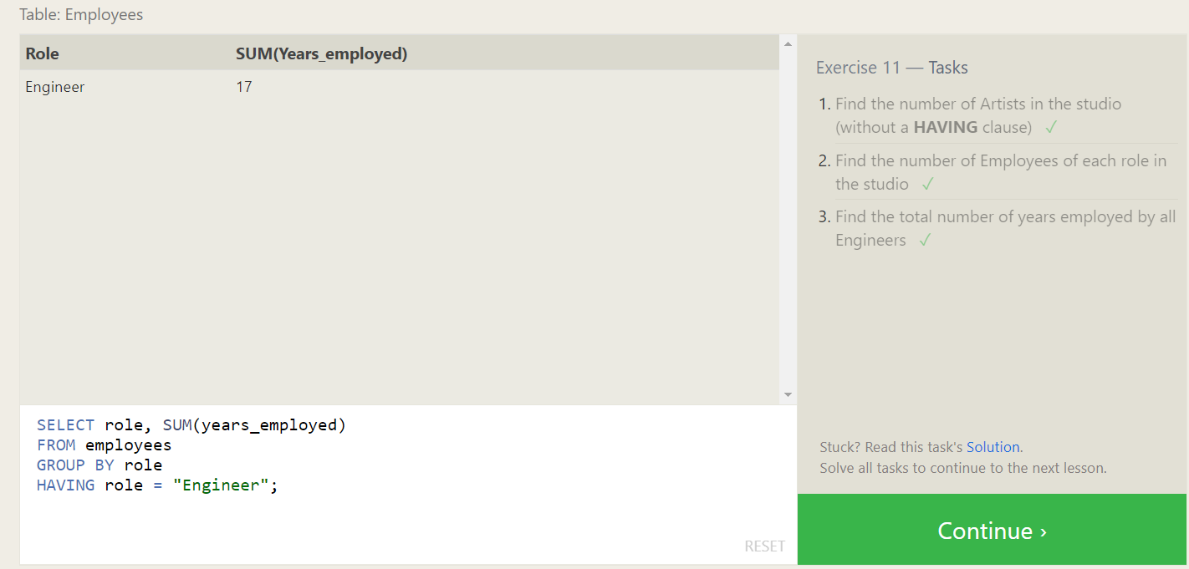

**Exercise 12: Order of execution of a Query**

1. SELECT director, COUNT(id) as Num_movies_directed FROM movies GROUP BY director;
2. SELECT director, SUM(domestic_sales + international_sales) as Cumulative_sales_from_all_movies FROM movies INNER JOIN boxoffice ON movies.id = boxoffice.movie_id GROUP BY director;

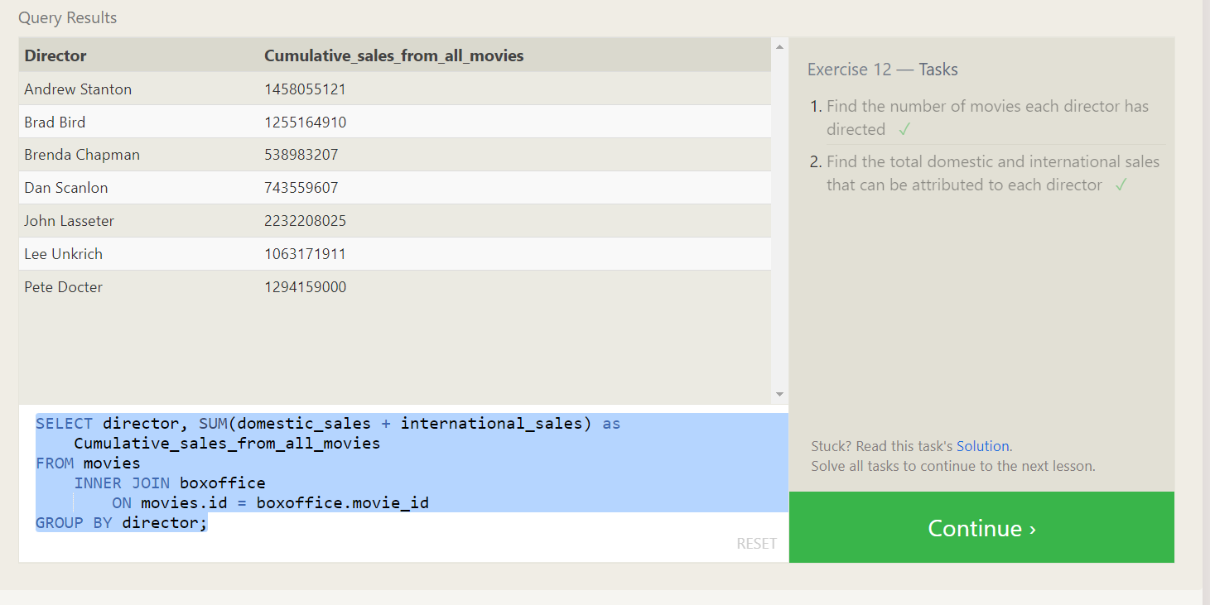

**Exercise 13: Inserting Rows**

1. INSERT INTO movies VALUES (10, "Toy Story 4", "John Lasseter", 2015, 90);
2. INSERT INTO boxoffice VALUES (4, 8.7, 340000000, 270000000);

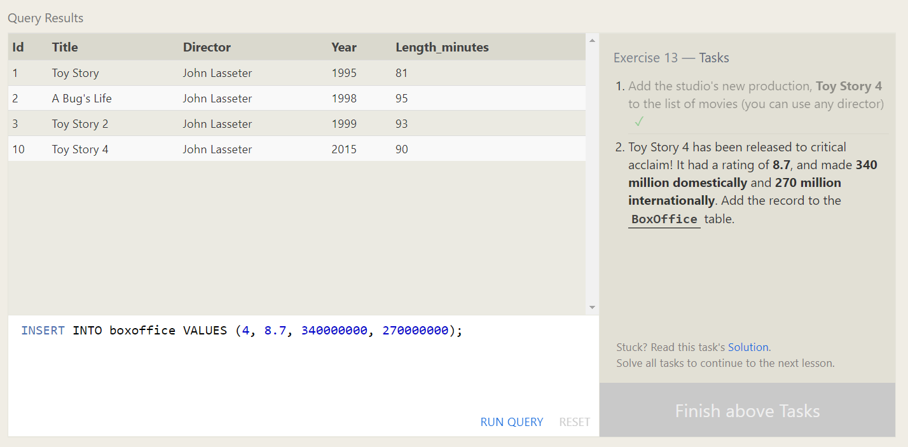

**Exercise 14: Updating Rows**

1. UPDATE movies SET director = "John Lasseter" WHERE id = 2;
2. UPDATE movies SET year = 1999 WHERE id = 3;
3. UPDATE movies SET title = "Toy Story 3", director = "Lee Unkrich" WHERE id = 11;

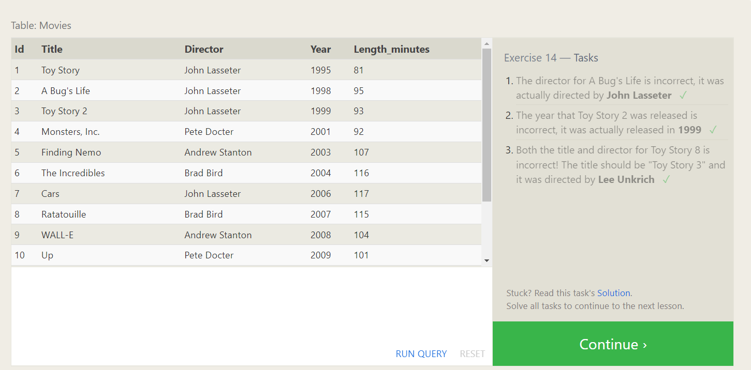

**Exercise 15: Deleting Rows**

1. DELETE FROM movies where year < 2005;
2. DELETE FROM movies where director = "Andrew Stanton";

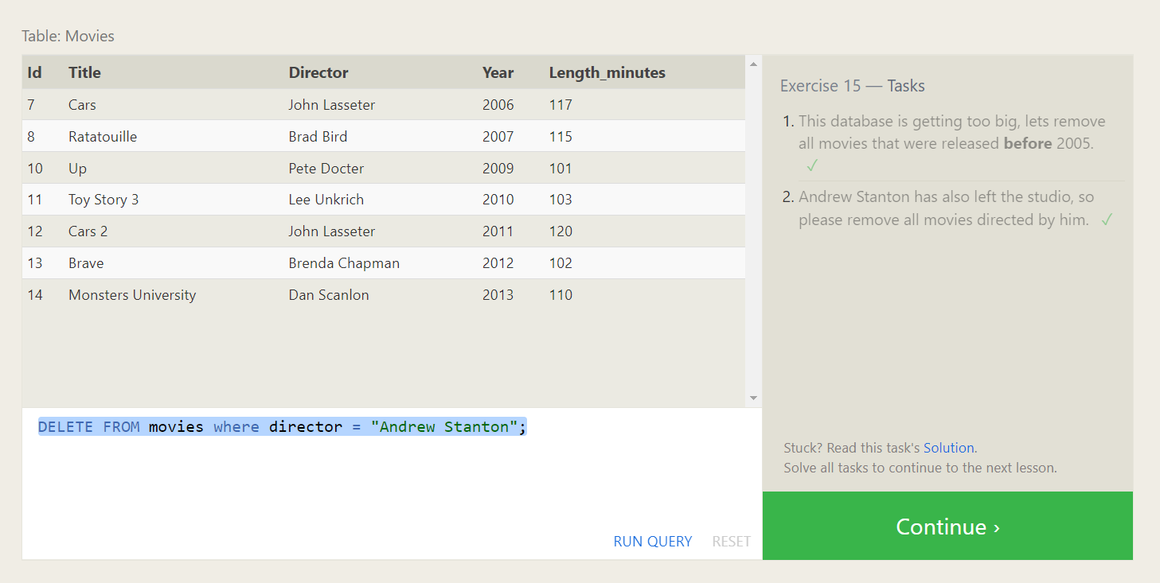

**Exercise 16: Creating Tables**

1. CREATE TABLE Database (

Name TEXT,

Version FLOAT,

Download_count INTEGER

);  
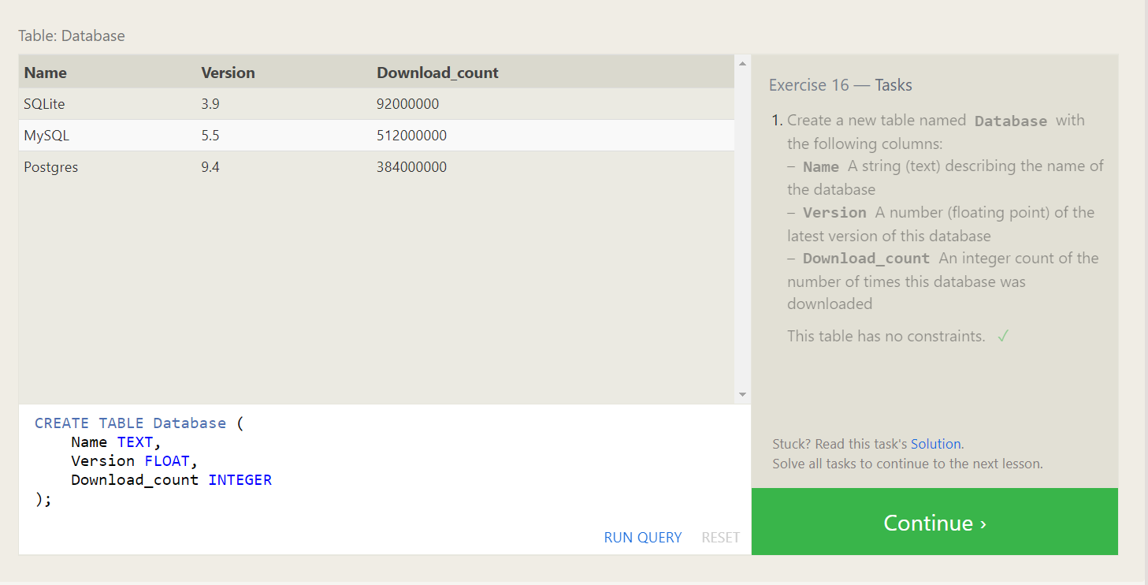

**Exercise 17: Altering Tables**

1. ALTER TABLE Movies

ADD COLUMN Aspect_ratio FLOAT DEFAULT 2.5;

2. ALTER TABLE Movies

ADD COLUMN Language TEXT DEFAULT "English";

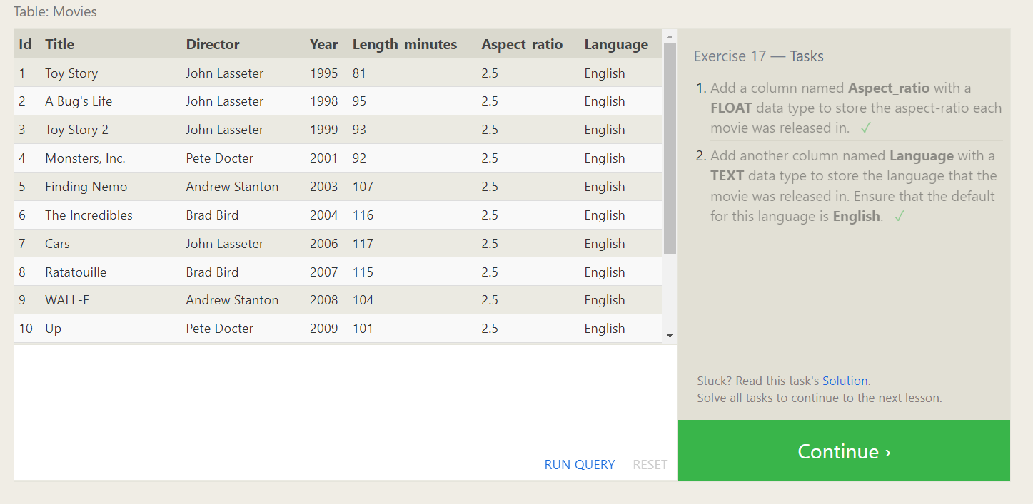

**Exercise 18: Dropping Tables**

1. DROP TABLE Movies;
2. DROP TABLE BoxOffice;

